1. Screenshot of Kanban Board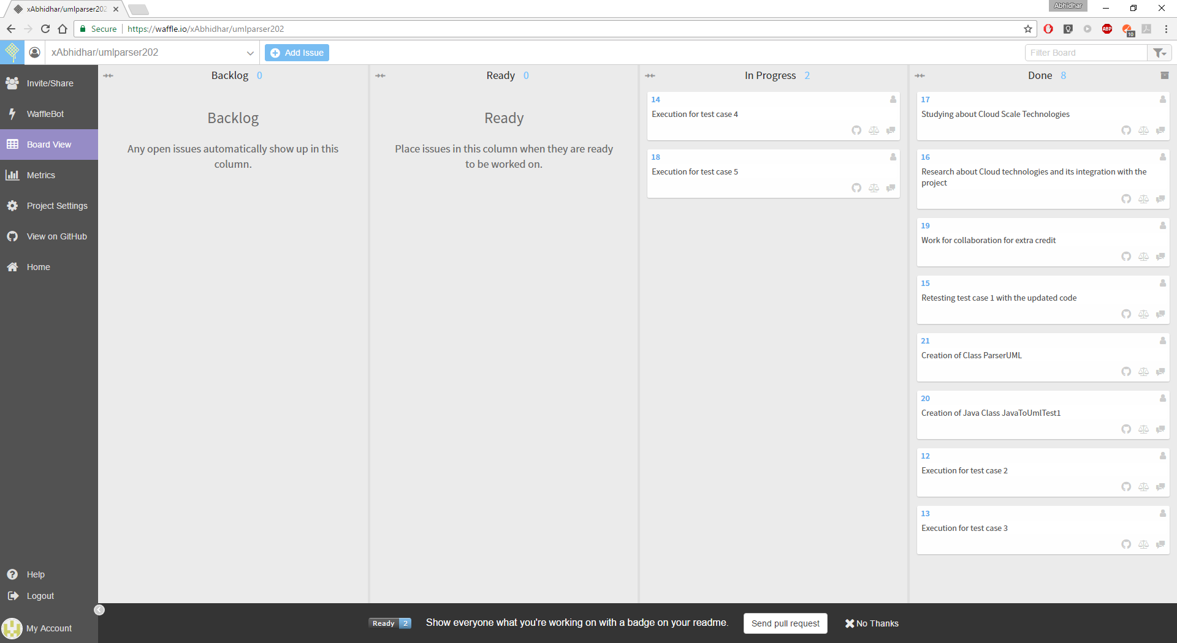
2. URL Link to the Waffle Board  
   <https://waffle.io/xAbhidhar/umlparser202>
3. URL Link to the GitHub Repo  
   <https://github.com/xAbhidhar/umlparser202>
4. **“** ​Wait time” for all the cards in the “In Progress” column and “Total cycle time” for all the cards  
   in the “Done” column

|  |  |  |  |  |
| --- | --- | --- | --- | --- |
| **Card Number** | **Card** | **Column** | **Wait Time** | **Cycle Time** |
| 1 | Gathering requirements | Done | - | 2 Days |
| 2 | Understanding Waffle | Done | - | 1 Day |
| 3 | Understanding GitHub | Done | - | 1 Day |
| 4 | Environment setup - Setting up Java | Done | - | 1 Day |
| 5 | Selecting and finalizing which Parser to use | Done | - | 1 Day |
| 6 | Studying about UML generator | Done | - | 2 Days |
| 7 | Drafting a BRD (Business Requirement Document) | Done | - | 1 Day |
| 8 | Creation of test cases | Done | - | 2 Days |
| 9 | Selecting UML diagram generator | Done | - | 1 Day |
| 10 | Integrating PlantUML in eclipse | Done | - | 1 Day |
| 11 | Execution of test case 1 | Done | - | 2 Days |
| 12 | Execution of test case 2 | Ready | - | 2 Days |
| 13 | Execution of test case 3 | Ready | - | 2 Days |
| 14 | Execution of test case 4 | Ready | 1 | - |
| 15 | Retesting test case 1 with the updated code | Ready | - | - |
| 16 | Research about Cloud technologies and its integration with the project | Done | - | 2 Days |
| 17 | Studying about Cloud Scale Technologies | Done | - | 1 Day |
| 18 | Execution of test case 5 | Ready | - | - |
| 19 | Work for the collaboration for the extra credit | Ready | - | 2 Days |
| 20 | Creation of Java Class JavaToUmlTest1 | Ready | - | 1 Day |
| 21 | Creation of Class ParserUML | Ready | - | 1 Day |